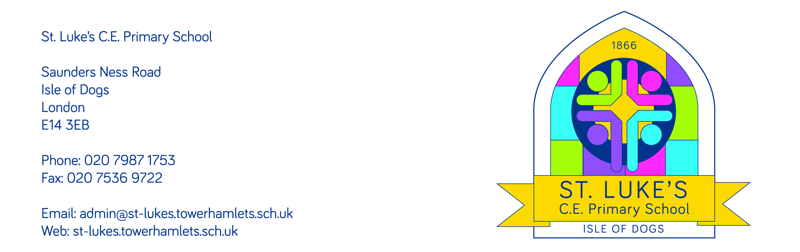
13 April 2021

Dear parents and carers,

RE: Parent consultations

Due to the disruption last term, we had to rearrange the dates for the parent consultations planned for the Spring term. Below you will see the new dates to meet with your child’s class teacher. Please note that for Nursery meetings, parents of children who attend in the morning and afternoon can book in for either date.
Date | Class
Monday 19th April | 1S - Beech
 | 4A - Spruce
Wednesday 21st April | 3B - Oak
 | 5D - Palm
Thursday 22nd April | 3T – Lemon
 | 4G - Aspen
 | 6L - Willow
Friday 23rd April | 1B - Maple
 | 2N - Birch
 | 6W - Cypress
 | Nursery
Monday 26th April | 5B – Cherry
Wednesday 5th May | Reception Apple
Friday 7th May | Nursery
Monday 10th May | Reception Peach

These meetings will all take place on Zoom. Prior to your meeting, a Zoom link will be sent to you so that you can join the meeting. Class teachers will be available from 9:30 to 5pm for 10-minute appointment slots. In order to book your time, please ring the school office from Wednesday 14th April. If you would prefer a telephone call rather than a Zoom call, please state this when booking via the school office.

We hope that you find these meetings helpful, and I know that class teachers are looking forward to meeting with you to discuss your child’s progress, and to answer any questions you may have.

Yours sincerely,

Cristina King
Head of School

