Asthma and Allergy Policy
St Luke’s Primary School

Approved by: |  | Date:
Last reviewed on: | 16 March 2021
Next review date: | March 2023

Asthma Lead: Louise Emms
Allergy Lead: Louise Emms

Contents
Purpose 3
Background 3
Recognising poorly controlled asthma 4
How to recognise and act in emergencies 5-6
Summary of Allergy and Asthma Friendly Schools Criteria 7
Asthma and allergy register 8
Medications 9-10
Care plans 11
School environment and triggers 12
Exercise and activity 12
When asthma and/or allergies are affecting a pupil’s education 13
“Spare” emergency Salbutamol inhalers and AAI(s) in schools 14-15
Asthma and allergy lead(s) responsibilities 16
All staff training 16
References 17
Appendix 1 Asthma register 18
Appendix 2 Record of administration 19
Appendix 3 GP notification asthma control concerns 20
Appendix 4 Opt-in consent emergency kit use 21
Appendix 5 Opt-out consent emergency kit use 22
Appendix 6 Self-certification audit checklist 23
Appendix 7 Emergency kit checklist 24
Appendix 8 Emergency inhaler used – template letter to parents 25
Appendix 9 September asthma spike - template letter to parents 26
Appendix 10 Emergency asthma poster 27
Appendix 11 Emergency anaphylaxis poster 28
Appendix 12 Request emergency inhalers -template letter to pharmacy 29
Appendix 13 Request emergency Adrenaline auto-injectors - template letter to pharmacy 30
Appendix 14 Review check list 31
Appendix 15 Asthma Action Plan 32-33
Appendix 16 Allergy Action Plan Epipen® 34
Appendix 17 Allergy Action Plan Emerade® 35
Appendix 18 Allergy Action Plan Jext® 36

Appendix 19 How to use and wash a spacer 37
Appendix 20 Resources 38
Appendix 21 Local contact information 39

Purpose
- Manage children & young people with asthma and food allergies effectively and safely at school.
- Support the appropriate use of salbutamol inhalers and adrenaline auto-injectors in emergencies.
- Reduce school absence and indirectly improve academic performance.
- Empower school staff to identify children with poorly controlled asthma.
- Improve asthma and allergy-related communication between education and health services.

Background

Asthma is a condition that affects the small tubes (airways) that carry air in and out of the lungs. When a person with asthma comes into contact with something that irritates their airways (an asthma trigger), the muscles around the walls of the airways tighten so that the airways become narrower. Secondly, the lining of the airways becomes inflamed and starts to swell. Sometimes, sticky mucus or phlegm builds up, which can further narrow the airways. These reactions make it difficult to breathe, leading to symptoms of asthma. To treat these symptoms children and young people need to take an inhaler (usually Salbutamol, “the blue pump”) through a spacer (plastic tube with mouthpiece that ensures correct delivery of the medicine to the lungs and reduces side effects).

Wheeze is the high-pitched, whistling sound made by the small airways when they become inflamed.
Viral wheeze is a common condition whereby preschool children become wheezy only when they have a cold. Most children will grow out of this with age. It does not necessarily mean they will go on to develop asthma.

Acute attacks of both viral wheeze and asthma can be life-threatening. Thankfully, the emergency treatment is broadly the same for each condition; similarly, preventative treatment of recurrent viral wheeze mirrors that of asthma.

Recognising poorly controlled asthma
We recognise that some of the most common day-to-day symptoms of asthma are:
- Dry cough
- Wheeze (a ‘whistle’ heard on breathing out)
- Excessive shortness of breath on exercise or when exposed to a trigger
- Tight chest
These symptoms are usually responsive to the use of the child’s Salbutamol inhaler and rest (e.g. stopping exercise). As per Department of Health document; they would not usually require the child to be sent home from school or to seek urgent medical attention if they improve after taking their Salbutamol inhaler. However, if the child requires their Salbutamol more than twice a week, this is a sign of poor asthma control and the school asthma lead will need to be informed. The asthma lead can discuss the child with the community asthma nurse to decide on the most appropriate location for review. This can be either the child’s own GP surgery, the community asthma nurse clinic or occasionally in the hospital by the specialist asthma team.

What to do in an emergency

Recognising an acute asthma attack
- Persistent cough (when at rest)
- A wheezing sound coming from the chest (when at rest)
- Difficulty breathing (the child could be breathing fast and with effort, using the accessory (supporting) muscles in the upper body)
- Nasal flaring
- Unable to talk or complete sentences. Some children will become very quiet.
- May try to tell you that their chest ‘feels tight’ (younger children may express this as tummy ache)
We also recognise that we need to call an ambulance immediately and commence the asthma attack procedure without delay if the child;
- Appears exhausted.
- Is going Blue.
- Has collapsed.

Actions in the event of an asthma attack (see appendix 10):
- Keep calm and reassure the child.
- Encourage the child to sit up and slightly forward.
- Use the child’s own inhaler – if not available, use the emergency inhaler.
- Remain with the child while the inhaler and spacer are brought to them.
- Shake the inhaler, remove the cap and place inhaler in spacer.
- Place the mouthpiece of the spacer between the lips of the child. Make sure there is a good seal.
- Help the child to take two puffs of salbutamol (blue inhaler) via the spacer. (One puff to 10 breaths, therefore 2 puffs equals 20 breaths).
- If there is no improvement, repeat these steps up to a maximum of 10 puffs (100 breaths).

- If the child does not feel better or you are worried at ANYTIME before you have reached 10 puffs,
  - Call 999 FOR AN AMBULANCE and call for parents/carers.
  - If an ambulance does not arrive in 10 minutes give another 10 puffs.
  - If the CYP also has an adrenaline auto-injector, give this too. Anaphylaxis could be the cause of their breathing issues.
  - A member of staff will always accompany a child taken to hospital by ambulance and will stay with them until a parent or carer arrives.
- If the child does feel better
  - Stay with the child until they no longer cause concern.
  - The child can return to school activities when they feel better.
  - Inform the parents/carers and advise that they should make an appointment with the GP or their asthma nurse.
  - If the child has had to use 6 puffs or more in 4 hours the parents should be made aware urgently and the CYP should be seen by their usual doctor/nurse as soon as possible.
Anaphylaxis is a severe and often sudden onset allergic reaction. It occurs when a susceptible person is exposed to an allergen (e.g. food, animal, insect sting). Allergic reactions can start mild and become worse with time if not treated. They usually begin within minutes of allergen exposure and can rapidly progress, but also can appear up to 2 hours later. Severe reactions can be life-threatening and always require an immediate emergency response, including the administration of an adrenaline auto-injector (AAI) also called an adrenaline pen.

Many children with anaphylaxis (not just those with a background of asthma) can develop breathing problems similar to an asthma attack.

Recognising mild-moderate allergic reactions
- Swollen lips, face or eyes
- Itchy/tingling mouth
- Hives or itchy skin rash
- Tummy pain or single episode of vomiting
- Sudden change in behaviour

Actions in the event of a mild-moderate allergic reaction
- Stay with the child and call for help if necessary.
- Locate the child’s adrenaline pen (AAI) and the emergency kit.
- Give antihistamine according to the child’s allergy action plan.
- Phone parent / emergency contact.
- Watch for signs of anaphylaxis.
The pupil does not normally need to be sent home from school, nor do they require urgent medical attention. However, mild reactions can develop into anaphylaxis: children having a mild-moderate (non-anaphylactic) reaction should therefore be monitored for any progression in symptoms for one hour or until symptoms resolve, whichever is the shorter.

Recognising anaphylaxis
- Persistent cough (interfering with breathing)
- Hoarse voice
- Difficulty swallowing / swollen tongue
- Difficult or noisy breathing
- Wheeze
- Persistent dizziness
- Becoming pale or floppy
- Sudden sleepiness / collapse / loss of consciousness

Actions in the event of anaphylaxis (see appendix 11)
If ANYONE (or more) of the above signs are present:
- Lie the child flat with legs raised (if breathing is difficult allow the child to sit up)
- Use Adrenaline autoinjector WITHOUT DELAY. Take note of time given.
- Dial 999 to request ambulance and say ANAPHYLAXIS (AN-A-FIL-AK-SIS). Give clear and precise directions to the emergency operator, including the postcode of your location.
- Stay with the child until ambulance arrives. DO NOT stand the child up.
- If there are no signs of life commence CPR
- Phone parent / emergency contact
- If there is no improvement after 5 minutes, give a further dose of adrenaline using a second autoinjector device. Take note of time given.
- Make a second call to the emergency services to confirm that an ambulance has been dispatched.
- Send someone outside to direct the ambulance paramedics when they arrive.

Always use an adrenaline auto-injector FIRST in someone with known food allergy who has SUDDEN BREATHING DIFFICULTY (persistent cough / hoarse voice / wheeze); even if no skin symptoms are present.
Summary of asthma and allergy friendly school criteria
Our school welcomes all pupils with asthma and allergies and aims to support these children in participating fully in school life.
We will do this by ensuring that that we have:
- An asthma and allergy policy, including the use of emergency inhalers and adrenaline auto-injectors.
- A register of all children and young people with asthma and allergies, to include all those who have been prescribed a salbutamol inhaler, antihistamine or adrenaline auto-injector in the preceding 12 months.
- An emergency kit including salbutamol inhalers, spacers, antihistamines and adrenaline auto-injectors.
- One or two named individuals responsible for adherence to asthma and allergy friendly school standards in the school.
- Yearly all staff training on awareness, correct use of associated medical devices and emergency policies.

Each child on the asthma and allergy register must have:
- An individual health care plan (IHCP, also called a management/action plan). While you are waiting for this make sure they have generic asthma poster.
- Personal medication and spacers clearly labelled and stored safely, within date, and easily accessible as near to them as possible.
- Parental consent for use of the emergency kit (and “spare” adrenaline devices if held by the school).

Asthma and Allergy Register
- An asthma and allergy register of children is held in the school and is updated yearly and when required (see appendix 1 for example).
- Parent/guardian of new pupils will be required to complete a medical declaration form when joining school and at the start of each new school year. This will specifically document:
  - Any physician-diagnosed of asthma and viral wheeze
  - Any prescription of a reliever inhaler (salbutamol/terbutaline, blue pump) in the preceding 12 months.
  - Any previous severe allergic reactions including any associated acute triggers/allergens.
  - Any prescription of an adrenaline pen (AAI) in the preceding 24 months.

- Parents/guardians are responsible for informing the school if there are any changes to their child’s needs, so that the register can be maintained up to date.
- Each child on the asthma and allergy register must have:
- An up-to-date¹ copy of their IHCP (personal asthma and/or allergy action plan²) signed by a medical professional.
- Their reliever inhaler (salbutamol, ‘blue pump’) in school with an age appropriate spacer (with a mouthpiece if over 4 years old).
- 2 adrenaline pens (AAIs) if previous severe allergic reactions³
- Parental/guardian consent to use the medications in the emergency kit at school.

We advise that all children prescribed a salbutamol inhaler within the last 12 months but without a formal diagnosis of asthma are also included on the register, so that the emergency inhaler can also be made available to them with the consent of the parents/carer.

Medications

Inhalers and spacers
All children with asthma should have immediate access to their reliever (usually the Salbutamol, blue inhaler⁴) at all times. The reliever inhaler is a fast-acting medication that relaxes the airway muscles, opening them up and making it easier for the child to breathe. It is always taken through an age-appropriate spacer (with a mask under 4 years of age, and a mouthpiece over 4 years of age⁵).
Some children will also have a preventer inhaler (brown/orange/purple/red), which is usually taken morning and night, as prescribed by the doctor/nurse. This medication needs to be taken regularly for maximum benefit. Children should not routinely bring their preventer inhaler to school as it should be taken regularly at home as prescribed by their doctor. However, if the pupil is going on a residential trip, they will need to take the inhaler with them for use at the start and end of the day. It is not helpful during an acute asthma attack.
Our staff are not usually required to administer asthma medicines to pupils. However, some children have poor inhaler technique, are severely unwell, or are otherwise developmentally unable to take the inhaler by themselves. Failure to receive their medication promptly could in extreme circumstances result in hospitalisation or even death. Staff who have had asthma training and are happy to support children as they use their reliever inhaler, can be essential for the well-being and safety of the child. If there are concerns over a child’s ability to use their inhaler advice will be given to the parents/carers to arrange a review with their GP and/or discuss this with the community asthma nurse.

Adrenaline Auto-injectors
- Antihistamines can be useful for mild allergic reactions but are ineffective in severe reactions.
- First line treatment for a severe allergic reaction is administration of an adrenaline auto-injector (AAI) as an injection into the thigh muscle. If there are any signs of a severe reaction the AAI should be administered immediately and should not be delayed until after inhalers or antihistamines have been given.
- Employing a “wait-and-see” policy will delay effective treatment and may result in serious illness or death. AAI devices (current brands available in the UK are EpiPen®, Emerade®, Jext®) contain a single fixed dose of adrenaline (size of dose dependent on age), which can be administered by non-healthcare professionals such as family members, teachers and first-aid responders. The use of adrenaline pen as described is safe and can be life-saving.
Children who are considered at higher risk of anaphylaxis will have been prescribed AAIs by their GP for use in an emergency. The consensus recommendation from multiple bodies has been that an individual should always have 2 adrenaline auto-injectors available at all times. This is because on occasion an AAI device may be used incorrectly or may misfire, additionally, severe reactions may require more than one dose of adrenaline. Children may initially improve but then deteriorate later, therefore it is essential to call 999 for an ambulance whenever a severe allergic reaction occurs, even if the pupil has apparently completely recovered.
At St. Luke’s we require all children who have AAIs prescribed to have two, in date, in school.
In our school the AAIs are kept in the red medication ruck sacks designated for each class and these ruck sacks accompany the children wherever they are for example; PE lessons, lunch times and on trips as well as when they are in the classroom. AAIs should not be located more than 5 minutes away from where they may be needed.
Parents and guardians will need to make sure that in addition to the AAIs held in school, the child has access to an additional two at home and one for their journey to and from school. As children get older, and walk to and from school by themselves, the Asthma and Allergy Lead will liaise with the child and their parents/guardian for the safe keeping of the AAIs used on journeys in school during the school day.
We ask that parent/guardian to sign their consent (clearly marked on the allergy management plan) allowing for the administration of the generic adrenaline devices in the case of exceptional circumstances. Please note that we have been advised to contact the School Health team who will alert the local allergy service so they can discuss it with the family at the next outpatient appointment or by telephone, if a parent/guardian choose not to give consent.

NOTE – “Spare” adrenaline auto-injectors
The MHRA recommends that those prescribed AAIs should have TWO devices available, at all times. In 2017 government legislation was introduced allowing schools to purchase adrenaline auto-injectors that would be owned and managed by the school. The idea was to increase the provision of adrenaline auto-injectors in the school environment and that these devices could be used on any pupil suffering a severe allergic reaction.

Care Plans

Asthma Action Plans
Asthma UK evidence shows that if someone with asthma uses a personal asthma action plan, they are four times less likely to be admitted to hospital due to their asthma. Therefore, it is essential that all children with asthma have a personal asthma action plan at school to ensure their asthma is managed effectively within school and to prevent hospital admissions. The asthma plan needs to have been completed by a healthcare professional. Plans in the appendix can be sent to the GP to complete. The school nursing team will support the schools but will not be completing the plans.

Allergy Action Plans
Allergy action plans are designed to facilitate first aid treatment of an allergic reaction by people *without* medical training. They provide medical and parental consent for schools to administer medicines in the event of an allergic reaction (including “spare” AAIs if held at the school). They need to be completed by a healthcare professional and will be typed (not handwritten) with logos indicating which organisation provided them. At St. Luke’s we will print the plans provided in appendix and ask parents and guardians to share these with their GP or healthcare professional to complete.
Pupils who have been assessed to have a low risk of having a severe allergic reaction (and so do not have adrenaline prescribed to them) will have a “mild/moderate” allergy management plan given to them and our school. The mild/moderate plans still mention when to give adrenaline (i.e. if there is a severe allergic reaction) as there is no 100% guarantee that an allergic person will never have a severe reaction. Therefore, guidance is placed on all allergy management plans in this country and abroad so that anyone attending a child who is having an allergic reaction can make an assessment of the severity of that reaction and act accordingly. Not all children are prescribed an adrenaline device, therefore if the person attending the child believes a severe allergic reaction is occurring then they must call 999 (for the UK) so that treatment can be administered as soon as possible. If there are “spare” AAIs at school, then these should be used (if parents have signed the consent on the allergy management plan) and this is why even the mild/moderate allergy management plans say to give an adrenaline device if there is one available.

School environment and triggers
The school does all that it can to ensure that the school environment is favourable to pupils with asthma and allergies.
- The school has a definitive no-smoking policy.
- Pupil’s asthma and allergy triggers will be recorded as part of their asthma and allergy action plans. The school will ensure that pupil’s will not come into contact with their triggers, where possible.
We are aware that triggers for asthma can include:
- Colds and infection
- Dust and house dust mite
- Pollen, spores and moulds
- Feathers
- Furry animals
- Exercise, laughing
- Stress
- Cold air, change in the weather
- Chemicals, glue, paint, aerosols, perfume
- Food allergies
- Fumes, pollution and cigarette smoke
We are aware that common allergens that can trigger anaphylaxis are:
  - Foods (e.g. nuts, milk/dairy foods, egg, wheat, fish/seafood, sesame, soya)
  - Insect stings (e.g. bee, wasp)
  - Medications (e.g. antibiotics, pain relief such as ibuprofen)
  - Latex (e.g. rubber gloves, balloons, swimming caps)

Exercise and activity
Taking part in sports, games and activities is an essential part of school life for all pupils. This includes pupils with asthma and allergies.
- All staff will know which children in their classes have asthma. This is particularly important for PE teachers.
- Pupils with asthma are encouraged to participate fully in all activities.
- PE staff will remind pupils whose asthma is triggered by exercise to take their reliever (usually Salbutamol, blue inhaler) via spacer if beneficial before the lesson, and to thoroughly warm up and down before and after the lesson.
- It is agreed with PE staff that pupils who are mature enough will carry their inhaler and spacer with them and those that are too young will have their inhaler and spacer labelled and kept in a Red Medical Rucksack at the site of the lesson.
- If a pupil needs to use their inhaler during a lesson they will be encouraged to do so (using a spacer). The use of the inhaler will be documented.
- If a pupil regularly has excess shortness of breath, chest tightness or cough with exercise, this will be communicated to the school asthma lead AND school nurse. These are signs of poor asthma control and need review by a medical professional.

School trips
Schools should conduct a risk-assessment for any pupil at risk of anaphylaxis or wheeze taking part in a school trip off school premises, in much the same way as they already do so with regards to safeguarding etc. Pupils at risk of anaphylaxis or wheeze should have their AAI/reliever inhaler with them, and there should be staff trained to administer AAI in an emergency. Schools may wish to consider whether it may be appropriate, under some circumstances, to take spare AAI(s)/reliever inhalers obtained for emergency use on some trips.

Impact on education
The school are aware that the aim of asthma and allergy medication is to allow CYP to live a normal life. Asthma and/or allergies can impact on the life of a pupil by making them:
- unable to take part in normal activities (for example PE)
- tired during the day.
- fall behind in lessons.
- have significant school absence.
If we recognise that a pupil’s education is affected by their condition, we will:
- Discuss this with the parents/carers.
- With consent, inform the school nurse and/or community asthma nurse.

“Spare” Emergency Salbutamol Inhalers and AAI(s) in school
As a school we are aware of the Department of Health guidance on ‘the use of emergency salbutamol inhalers in schools” and “the use of adrenaline auto-injectors in schools” from the Department of Health. We are aware as a school that we are able to purchase salbutamol inhalers, spacers and adrenaline auto-injectors from community pharmacists without a prescription.
- Any emergency inhaler and AAI held by a school should be considered a back-up device and is not a replacement for a pupil’s own medication as prescribed by their GP.
- The parents/carers will always be informed in writing if their child has used the emergency inhaler at school.
- Emergency services will be called immediately and parents/carers will be informed as soon as possible by phone if their child has received the emergency adrenaline auto-injector.
We have _____ emergency kit(s)⁶
They are kept easily accessible in
Each kit contains:
- A salbutamol metered dose inhaler (MDI)
- At least two spacers compatible with this inhaler
- Two adrenaline-autoinjectors at each available strength
- Instructions on using the inhaler with spacer
- Instructions on using the adrenaline auto-injector are on the side of the device and on the allergy management plan
- Instructions on cleaning and storing the inhaler
- Manufacturers’ information for inhalers and adrenaline auto-injectors
- A checklist of inhalers and adrenaline auto-injectors, identified by their batch number and expiry date, with monthly checks recorded;
- A note of the arrangements for replacing the inhalers, spacers and adrenaline auto-injectors;
- The name of the child permitted to use the emergency kit
- A record of any medication administration
The school will ensure that the emergency salbutamol inhaler will only be used by CYP who:
- Have asthma or who have been prescribed a Salbutamol inhaler AND
- For whom written parental consent has been given for use of the emergency kit.
We will ensure that the pupil’s allergy management plan is followed and emergency adrenaline auto-injector will only be used if indicated.
All allergy management plans MUST be signed by the parent/carer/guardian and held by the school as this represents signed consent to use the treatment if needed.
A “spare” adrenaline auto-injector will normally only be used on a CYP without the consent of parent/carer/guardian if emergency medical services (e.g. 999) or other suitably qualified person advises this.
Where doubt exists then the AAI should be used as unnecessary delays have been associated with death.
Maintaining the emergency kit
- Check monthly that the inhalers, spacers and AAIs are present and in working order, and that the inhaler has sufficient doses available and has greater than 3 months until expiry.
- Obtain replacement inhalers and AAIs if the expiry date is within 3 months.
- The inhaler can be reused, so long as it hasn’t come into contact with any bodily fluids. Following use, the inhaler canister will be removed, and the plastic inhaler housing and cap will be washed in warm running water and left to dry in air in a clean safe place. The canister will be returned to the housing when dry and the cap replaced. Return to emergency kit after cleaning and drying.
- The spacer cannot be reused. Replace spacers following use.
- Empty inhaler canisters will be returned to the pharmacy to be recycled.
- Before using a salbutamol inhaler for the first time, or if it has not been used for 2 weeks or more, shake and release 2 puffs of medicine into the air.
- The AAI devices should be stored at room temperature (in line with manufacturer guidance), protected from direct sunlight and extremes of temperature.
- Once an AAI has been used it cannot be reused and must be disposed of according to manufacturer’s guidance as it contains a needle
- Used AAIs can be given to ambulance paramedics on arrival or disposed of in a sharps bin (available from pharmacies or online) for collection by the local council.

Asthma and allergy lead(s) responsibilities
This school has asthma and allergy leads who are named above. It is the responsibility of these leads to:
- Update the asthma and allergy register,
- Update the asthma and allergy policy,
- Ensure measures are in place so that children have immediate access to their inhalers and AAIs.
- Maintain the emergency kits (see chapter above)

All Staff Training
It would be reasonable for ALL staff to:
- Know how to recognise:
  - poorly controlled asthma
  - an acute asthma attack
  - an acute severe allergic reaction (anaphylaxis)
- Be aware of the asthma and allergy policy
- Know how to check if a pupil is on the asthma and allergy register
- Know how to access the pupil’s own medications and the emergency kit
- Know which designated members of staff are trained to administer the medications and how to access their help.
NOTE – instructions on how to use an AAI are present on the device itself and on the allergy management plan.
Staff will have yearly asthma and allergy updates. This training can be obtained by:

- Webinar session Asthma and allergy from school health– https://youtu.be/aXFnaAXMHo4

- Via e-learning on the Education for Health website https://www.educationforhealth.org/allresources/free-elearning/

- Via e-learning for allergy https://www.anaphylaxis.org.uk/schools/schools-allergywise/

References

This guidance uses material from:
Asthma UK, ‘Asthma Facts and FAQs’,
http://www.asthma.org.uk/asthma-facts-and-statistics
Department of Health (2017). Guidance on the use of Adrenaline autoinjectors in schools. Available on: https://assets.publishing.service.gov.uk/government/uploads/system/uploads/attachment_data/file/645476/Adrenaline_auto_injectors_in_schools.pdf
Department of Health (2015). Guidance on the use of emergency inhalers in schools. Available on: https://www.gov.uk/government/uploads/system/uploads/attachment_data/file/416468/emergency_inhalers_in_schools.pdf
Healthy London Partnership (2016) London asthma standards for children and young people. Available on:
https://www.healthylondon.org/wp-content/uploads/2017/11/London-asthma-standards-for-children-and-young-people.pdf

Appendix 1 – Register template
Name | Class | Date of birth | Consent to use emergency inhaler | Consent to use emergency adrenaline auto-injector (AAI)

Appendix 2 – Record of medicine administration

Date | Child’s name | Time | Name of medicine | Dose  given  (no of puffs) | Spacer  cleaned  (tick) | Staff  Signature | Staff name (print in full)

Both the parents AND the school asthma lead should be notified if a student is using their reliever inhaler more than twice per week at school. (Not including prophylactic doses as stated on their care plan. For example, some students will use their inhaler routinely before PE.)

Please be aware of those students who carry their own inhaler and self-medicate.

Appendix 3 - GP letter template for asthma and allergy

tick what sections you are wanting from the GP
Royal London Hospital Paediatric Respiratory Service &
Tower Hamlets Children’s Community Nursing Team
Gerry Bennett Ward
Mile End Hospital
Bncroft Road
London, E1 4DG
Th.paedasthmanurse@nhs.net
Dear Dr
Name: DOB: NHS Number:
School:
The above child has been reviewed at school for their recurrent wheeze/asthma. The following concerns have been identified:
- They have poor wheeze / asthma control:
- They use salbutamol more than 2 times a week at school (not including prior to PE/Sports).
- They have significant reduced school attendance due to wheeze (<90% attendance).
- They experience disturbed sleep and/or exercise limitation due to wheeze/cough/chest tightness.
- Other___________________________________________________________________________________________________
- Their medication requires an update to allow for optimal drug delivery for their age. They will need:
- A new Salbutamol MDI inhaler
- A new spacer with mouthpiece. Example of appropriate spacers for age 5 years and above are:
- AeroChamber Plus Flow-Vu Anti-Static youth 5+ years (Trudell Medical UK Ltd)
- Able 2 Spacer (Clement Clarke International Ltd)
- Volumatic Spacer (GlaxoSmithKline UK Ltd)

Other spacer___________________________________________

- There is no up to date personalised wheeze / asthma action plan
- There is no up to date personalised wheeze / asthma action plan could you please complete and give to the family to bring back to school
- There is no Allergy Action Plan could you please complete and give to the family to bring back to school
- They need 2 auto injector pens at school
- They need to have emergency antihistamine
Actions Required from GP:
- This child’s parents have been advised to make an asthma review appointment at their GP practice within a month of the date of this letter. Would you please follow this up?
- Would you kindly prescribe the medications / spacer as suggested above?
- This child has been referred to the High Risk Community Wheeze and Asthma clinic in Tower Hamlets because of concerns about poor asthma control as detailed above. If you have any further details about this child that might assist with controlling their asthma, please get in touch.
Yours sincerely
Person completing letter:
Supported by Tori Hadaway Community Specialist Asthma Nurse

Appendix 4 - Opt-in consent for use of emergency kit
Child’s Name:………………………………..…
Child’s Class:……………………………….…
Child’s DOB:………………………………….
Date:……………………………………………
Wheeze/Asthma:
  - My child has been diagnosed with viral wheeze or asthma
  - My child has been prescribed a reliever inhaler (usually Salbutamol, blue inhaler)
  - My child has an in-date inhaler and spacer, clearly labelled with their name, which they will bring to school at the start of each new school year.
If my child shows symptoms of asthma and their own inhaler is not available or usable, I consent for my child to receive salbutamol from the emergency kit held by school.
Signed:……………………… Print Name:………………………………………………………………………...

Relationship to child……………………………………………………………………………………………………………
Severe food allergies:
- My child has been diagnosed with acute food allergies and has an allergy management plan

- My child has been prescribed an adrenaline autoinjector pen (Epipen® / Emerade® / Jext®)

- My child has an in-date adrenaline pen, clearly labelled with their name, which they will bring to school at the start of each new school year.

OR
- I have discussed with the school and signed the consent below to permit use of school supplied “spare” adrenaline devices if needed under care of the school.
Mild food allergies:
- My child has been diagnosed with acute food allergies and has an allergy management plan
If my child shows symptoms of a severe allergic reaction and their own adrenaline autoinjector is not available or usable, I understand that my child may receive the adrenaline pen from the “generic” emergency kit held by school if this is needed in order to save their life.
Signed:…………………………………………Print Name:………………………………………………………………………

Appendix 5 - Audit Check-list
This is a SELF VALIDATION check list to become an asthma and allergy friendly school. Return this form to provide evidence that you have met all essential criteria, and you will receive an Asthma and Allergy Friendly Schools certificate valid for a three-year period. Even so an annual review of asthma and allergic reaction management strategies should be undertaken by your school to ensure that policies and procedures are kept up to date.
To receive your certificate, please return this form via email to: th.paedasthmanurse@nhs.net
Name of School
Address
Contact Details (asthma Lead) | Name  Phone  Email  telephone
Type of School | Primary | Secondary
Number of pupils with asthma
Number of pupils with allergies
Total number of pupils
Total number of staff
Number of staff received asthma and allergy training

I declare that……………………………………………………………. (school name) has met the Asthma and Allergy Friendly Schools criteria and adopted an appropriate ‘Asthma and Allergy Friendly Schools’ Policy. I understand that Asthma and Allergy Friendly Schools status is awarded to schools as an acknowledgement of their ongoing commitment to promote ‘Asthma and Allergy Friendly’ behaviour through policy development and implementation, and a commitment to ‘Asthma and Allergy Friendly’ principles in daily operations.
Person competing form | Position
Signed: | Date:

Criteria | Completed
Asthma and Allergy Policy in place
Asthma and Allergy Register
Names and Dates of Birth of ALL children with asthma/wheeze /allergies who have been prescribed a reliever inhaler and/or adrenaline pen in the last 12 months.
Yearly Asthma and Allergy training for ALL staff
Webinar session Asthma and allergy from school health– https://youtu.be/aXFnaAXMHo4
Free online via http://www.supportingchildrenshealth.org
Free online allergy training via https://www.allergyuk.org/schools/whole-school-allergy-awareness-and-management
Asthma and allergy lead – is an individual responsible for:
Yearly ALL staff training
Up to date Asthma and Allergy register
Ordering emergency inhalers, spacers, adrenaline pens compliant with DoH guidance
Ensuring medications are in date
Children have immediate access to their own inhalers, spacers and adrenaline pens at all times (including school trips and when playing sport on school grounds).

Medications are labelled with their name in an easily accessible box.
This school has purchased emergency inhalers, spacers and adrenaline pens and created a minimum of 2 emergency asthma and allergy kits (see details on next page).
All children on the Asthma and Allergy register have a parental consent form signed for use of the emergency inhalers.
All children on the register have a personalised asthma and a separate allergy action plans (IHCP) if needed
See references in School policy for downloadable versions. To be completed by a health care professional.

Appendix 6 - Emergency Kit Check-list

An emergency wheeze / asthma kit includes: | Yes | No
At least 2 salbutamol metered dose inhalers (MDI) with manufacturer’s instructions and label for expiry date
At least 2 single-use spacers compatible with the inhaler
Instructions on how to administer the inhaler using spacer
Instructions on cleaning and storing the inhaler and spacer
An emergency allergic reaction kit includes: | Yes | No
At least 2 adrenaline-autoinjectors with manufacturer’s instructions and label for expiry date
Instructions how to administer the adrenaline auto-injector
In the school with emergency kits there are: | Yes | No
A record of the administration of any medication (i.e. when the medications have been used)
An Asthma and Allergy register which includes parental consent details for use of the emergency kit
The names of the Asthma and Allergy champions names along with contact details
Pharmacy name and contact details for replacement

For further information see reference page

Appendix 7 - Letter to parents after use of emergency inhaler
School Name
Child’s Name:
Class:
Date:
Dear ...................................................

This letter is to notify you that………………………………….has had problems with breathing today. This happened when…………………………………………………………………………………………….

They did not have their own asthma inhaler with them, so a member of staff helped them to use the emergency asthma inhaler containing salbutamol. They were given ………………… puffs.
Although they soon felt better, we would strongly advise that your child is seen by their own doctor as soon as possible.
Please can you ensure your child brings in an unopened, in-date inhaler and spacer for use in school. Both should be clearly labelled with your child’s name and date of birth.

Yours sincerely,

Appendix – 8 Template letter to parents September asthma spike
Royal London Hospital Paediatric Respiratory Service &
Tower Hamlets Children’s Community Nursing Team
Gerry Bennett Ward
Mile End Hospital
Bncroft Road
London, E1 4DG
Th.paedasthmanurse@nhs.net
Dear Parent/Carer,

Action Required – Wheeze and Asthma Attack Spike in September

As part of our school asthma policy, we would like to ensure that all our children with wheeze and/or asthma have a personal wheeze/asthma action plan in school. This allows us to support your child with their wheeze/asthma in school and will keep them safe during school hours.
If your child has not had a wheeze / asthma review in the last 12 months, please could we ask that:
a) you make an appointment with their GP for their annual asthma review.
b) ask the GP to complete a ‘personalised wheeze/asthma action plan’ for your child.
c) ask your GP for an extra salbutamol inhaler and spacer with mouthpiece rather than mask if school age to remain in school.
d) Bring the Salbutamol inhaler, the spacer and your child’s personalised wheeze/asthma action plan to the school office at the start of the new term.
Every year in September there is a peak in asthma attacks, due to weather changes and viruses going around. Hospital admissions are stressful for children and can potentially be dangerous and/or life threatening.
If children with wheeze/asthma return to school with their lungs in the best possible condition, then a wheeze/asthma attack maybe prevented.
Please also check the asthma UK website on https://www.asthma.org.uk/advice/manage-your-asthma/ for tips of how to manage your child’s asthma at home.

Thank you for your cooperation.
Yours sincerely,
Appendix 9 – Emergency poster Asthma

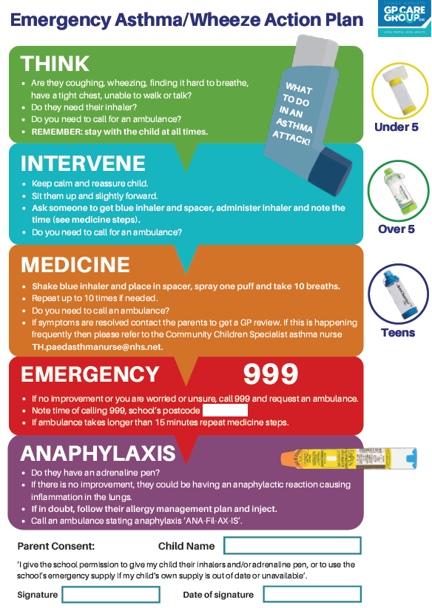

Appendix 10 - Emergency Poster Allergic Reaction (DOH)
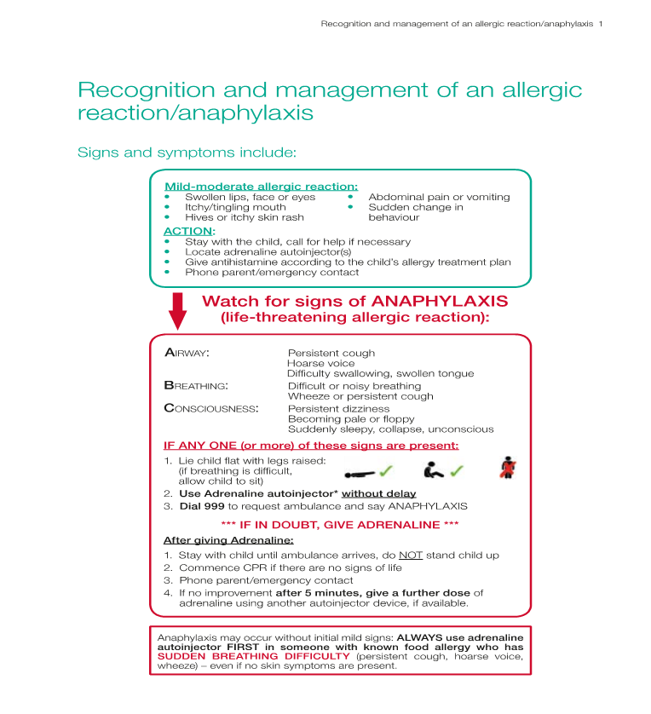

Appendix 11 - Pharmacy order template inhalers and spacers
Dear Pharmacist,
We are an asthma friendly school and as such have appropriate policies in place for the use, maintenance and disposal of emergency salbutamol inhalers and spacers.
We will ensure that the emergency salbutamol inhaler is only used by children > 5 years old who:
- Have asthma or who have been prescribed a Salbutamol inhaler in the last 12 months AND
- For whom written parental consent has been given.
In line with the legislation as stated in ‘The use of emergency salbutamol inhalers in schools’, from the Department of Health (2015), we would like to order:
ITEM | QUANTITY
Salbutamol MDI Inhaler
SUITABLE SPACERS WITH MOUTHPIECE
(choose 1 type for the whole school)
AeroChamber Plus Flow-Vu Anti-Static youth 5+ years (Trudell Medical UK Ltd)
Able 2 Spacer (Clement Clarke International Ltd)
Volumatic Spacer (GlaxoSmithKline UK Ltd)
Disposable Able Spacer Pack x 10 (Clement Clarke)

Name of School:
School postal address:
Phone number:
Head Teacher’s Full Name:

Head Teacher’s Signature

Appendix 12 - Pharmacy order template adrenaline pen (DoH)
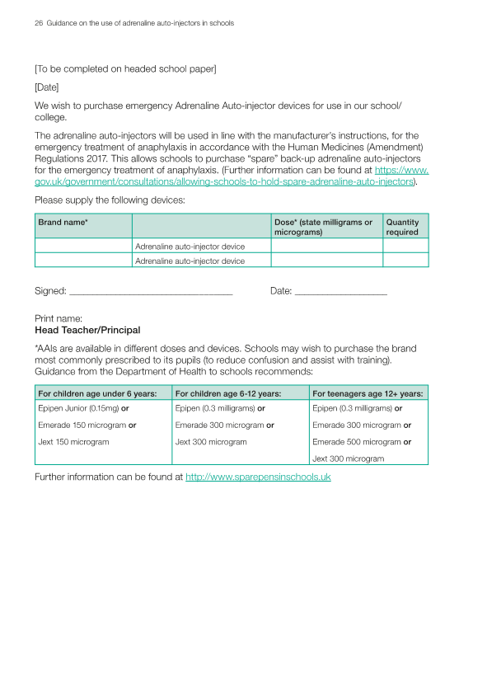

Appendix 13 - Asthma review checklist
Name: |  | DOB:
NHS#: |  | School:

General information and triggers | Yes/No
Does the child and family know what asthma is?
Does the child and family know their triggers and how to avoid them (exercise, animals, cold, weather change, foods, dust, tobacco smoke, pollen, pollution, anxiety/excitement ect…)?
Treatment | Yes/No
Has had inhaler technique explained and checked, knows the importance of using a spacer and knows how to clean their spacer?
Does the child know the role of the reliever and preventer medications?
Knows the importance of taking preventer regularly?
Care plans | Yes/No
Do they have an Asthma Action plan in place?
Do they need an allergy management plan? (if yes please also use the allergy checklist)
If you answer YES to any of the bellow please send a referral to the GP | Yes/No
Are they are using salbutamol more than 3 times a week excluding exercise?
Have they missed a lot of school due to asthma/wheeze symptoms?
They do not regularly use their preventer inhaler?
Have they had more than one course of prednisolone in the last 12 months?
Have they have had more than one hospital admission or A&E visit in the last 12 months?
They report using more than 10 salbutamol inhalers a year
They do not have an adequate number of Salbutamol inhalers at school (one on person/one in office)
They would benefit from an easibreathe salbutamol inhaler for use pre-sports (this is in addition to the MDI and spacer for emergency/exacerbation use).
They do not have a Volumatic inhaler at school?

Completed by:
Designation:
Date:

Appendix 14 Asthma Action Plan (Asthma UK)
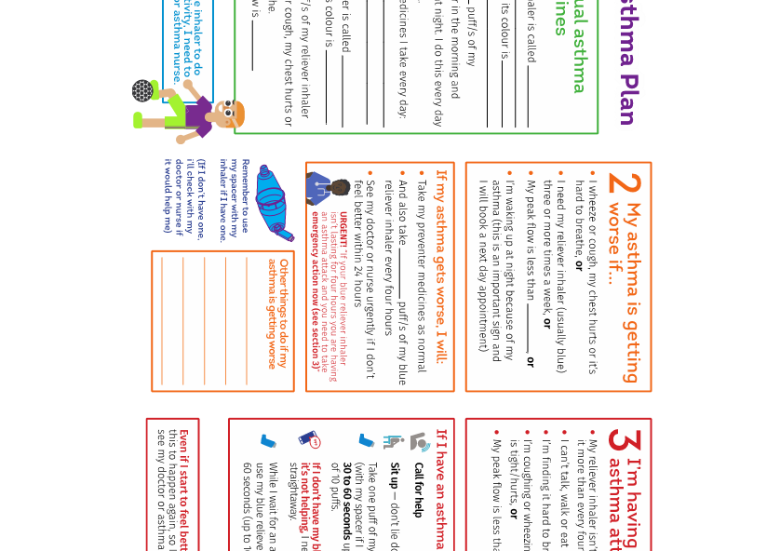
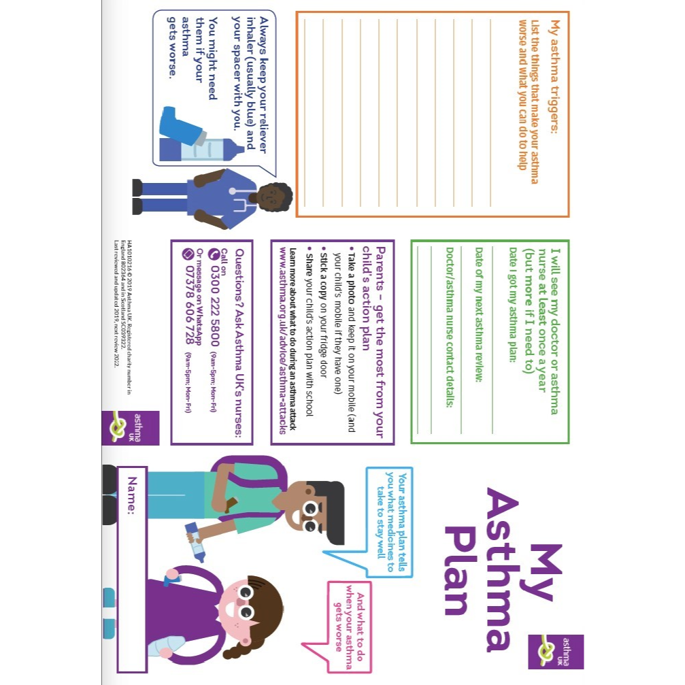

Appendix 15 Allergy Action Plan EpiPen
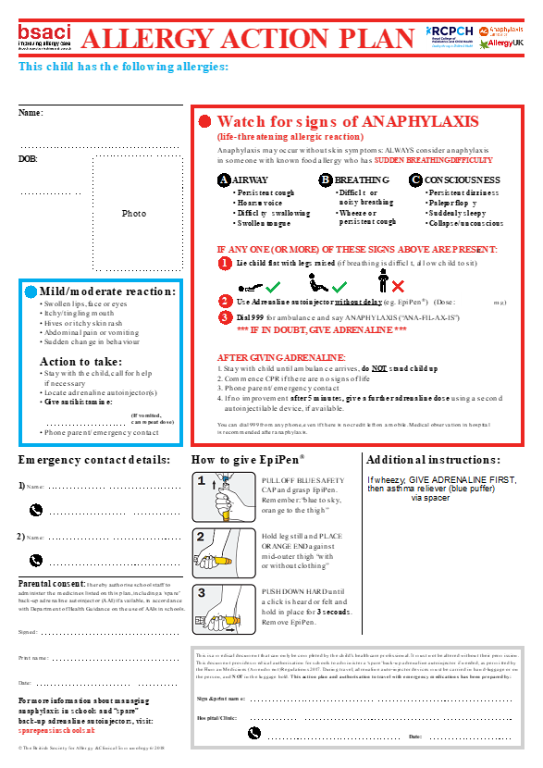

Appendix 16 Allergy Action Plan Emerade
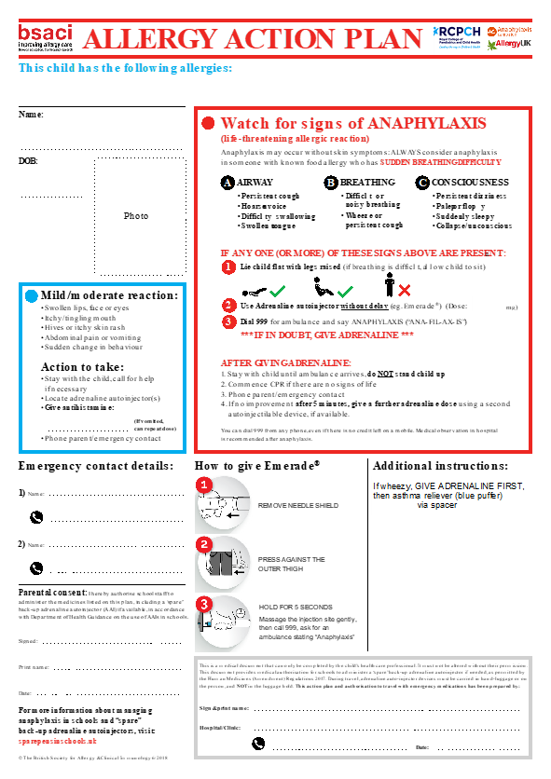

Appendix 17 Allergy action plan Jext
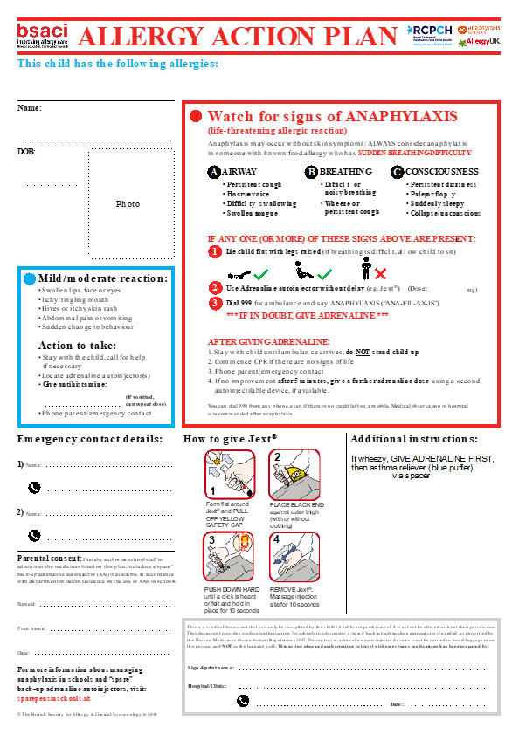

Appendix 18 How to use /wash a spacer
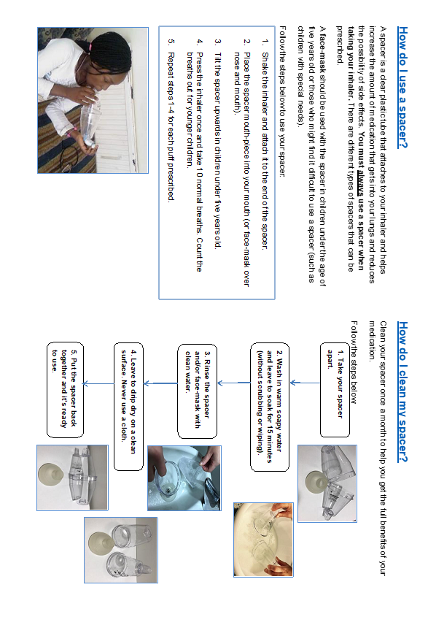

Appendix 19 Resources

Department of Health- Official guidance relating to supporting pupils with medical needs in schools:

https://assets.publishing.service.gov.uk/government/uploads/system/uploads/attachment_data/file/803956/supporting-pupils-at-school-with-medical-conditions.pdf

https://www.gov.uk/government/uploads/system/uploads/attachment_data/file/416468/emergency_inhalers_in_schools.pdf
https://assets.publishing.service.gov.uk/government/uploads/system/uploads/attachment_data/file/645476/Adrenaline_auto_injectors_in_schools.pdf

Allergy Links

Allergy UK https://www.allergyuk.org/
Whole school allergy and awareness management https://www.allergyuk.org/schools/whole- school-allergy-awareness-and-management
Anaphylaxis Campaign https://www.anaphylaxis.org.uk

Spare Pens in Schools http://www.sparepensinschools.uk

BSACI Allergy Action Plans available on https://www.bsaci.org/about/download-paediatric-allergy-action-plans

Asthma Links

Asthma UK Information for Schools. Available on: https://www.asthma.org.uk/advice/child/life/school?gclid=CjwKEAiAuKy1BRCY5bTuvPeopXcSJAAq4OVsZOzajkI3UrBTtR4F9ya8BL2UfYbaO3bhjeN13H_vRxoCcZjw_wcB

Asthma UK Asthma action plans. Available on: https://www.asthma.org.uk/a028677c/globalassets/health-advice/resources/children/myasthmaplan-trifold-final.pdf
Monkey wellbeing resourcs for schools. https://www.monkeywellbeing.com/

Generic medical conditions at school links
Schools Health Alliance. http://medicalconditionsatschool.org.uk/
Education for Health http://www.educationforhealth.org

Appendix 20 - Local Contact Information

School nursing team
thgpcp.schoolnurses@nhs.net

Community asthma nurse specialist tower hamlets
Tori Hadaway
th.paedasthmanurse@nhs.net
Mobile 07810630260

Children’s Community Nursing Team:
CCNT Tower Hamlets
Mile End Hospital
Bancroft Road
London, E1 4DG
Tel: 07591989962

Allergy nurse specialist Royal London Hospital
Frances Ling Frances.ling1@nhs.net

Smoking Cessation Team Tower Hamlets
Quit Right Tower Hamlets. Clients can self-refer.
http://quitrightth.org/
Tel : 020 7882 8230

