Remote Learning
Guidelines for Parents & Pupils

In the event of a school closure, St. Luke’s C of E Primary School will provide learning activities for children to access at home, on school days. We will provide a range of online and offline tasks, all focused on the learning for the child’s year group.
This information is intended to provide clarity and transparency to pupils and Parents or Carers about what to expect from remote education if local or national restrictions require entire cohorts (or bubbles) to remain at home.

The Remote Curriculum: What is taught to pupils at home?

Following the first few days of remote education, will my child be taught broadly the same curriculum as they would if they were in school?
We teach the same curriculum remotely as we do in school wherever possible and appropriate. However, occasionally, we may need to make some adaptations in some subjects. For example, in PE or Art, restricted access to resources may require adaptions to be made but also with a view to cover the original planned units later in the year.

Remote teaching and study time each day
How long can I expect work set by the school to take my child each day?
We expect that remote education (including remote teaching and independent work) will take pupils broadly at least three hours each day. Teachers will share a daily timetable with children. Here are details of what will be provided for each year group:

Remote Learning for Nursery

Each child will have a login to class dojo where they can access the weekly planning and submit their work.

On the class story page we will post the weekly planning by Monday morning. Parents can then click the link and review their child’s tasks for each day of the week.

The worksheets, powerpoints and videos outlined within the planning will be found through a link to google drive. There are also links in the planning to websites that can be used.

Teachers will set:

1x literacy/ communication and language

1x maths

1x other area of the curriculum

There will be 2 zoom sessions a day
    - 1x story time session for the morning class
    - 1x story time session for the afternoon class

All work needs to be posted in the child’s portfolio on Class Dojo.

A member of staff will look at what is posted, approve and comment on it.

Once approved it will be put into your child’s portfolio and they will receive a dojo point for it.

Parents/Carers are also encouraged to add any independent work children make (files, photos or videos) to their child’s portfolio.

If you need a printed pack of activities please notify a member of staff through Class Dojo and they can have one ready for you to collect from school.

Remote Learning for Reception Classes

Each child will have a login to Class Dojo where they can access the weekly planning and submit their work.

On the class story page we will post the weekly planning by Monday morning. Parents can then click the link and review their child’s tasks for each day of the week.

The worksheets, powerpoints and videos outlined within the planning will be found through a link to google drive. There are also links in the planning to websites that can be used.

Teachers will set:

1x Phonics

1x English

1x Maths

1x other area of the curriculum

There will also be one R.E session per week and some P.E activity ideas.
- Children will also have access to bug club for reading (if they are ready) or additional phonics activities/ daily sound introductions.

There will be 2 zoom sessions a day
    - 1x story time session- where an adult will read everyone a story chosen through a vote on class dojo
    - 1 x interactive session with either a wake up P.E session, share work session, or a special activity.

All work needs to be posted in the child’s portfolio on Class Dojo.

A member of staff will look at what is posted, approve and comment on it.

Once approved it will be put into your child’s portfolio and they will receive a dojo point for it.

Parents/Carers are also encouraged to add any independent work children make (files, photos or videos) to their child’s portfolio.

If you need a printed pack of activities please notify a member of staff through Class Dojo and they can have one ready for you to collect from school.

The small writing books can be used for practising independent sentence writing at their will Parents/Carers can collect packs from school

Online Remote Education for Years 1 - 6
- Children will have up to four tasks set by the teacher online, every school day. It will consist of:
  - A daily introduction from teachers to their pupils via Microsoft Teams
  - Teachers will set : 1 x English task
: 1 x Maths task
: 1 x Wider Curriculum topic task
: online/offline reading book of their choice
  - Weekly spellings will be on the class page on the school website. We ask that Parents/Carers practise with their child
  - Each year group will have two Zoom sessions a day, one in the morning, and one in the afternoon. The current timetable is below, but please note that this is subject to change, and the daily timetable will be made clear by class teachers every morning.
Class | Zoom 1 | Zoom 2
Early Years | 9:00 | 13:00
Reception | 9:20 | 12:40
Year 1 | 9:40 | 13:20
Year 2 | 10:00 | 13:40
Year 3 | 10:20 | 14:00
Year 4 | 11:05 | 14:20
Year 5 | 11:30 | 14:40
Year 6 | 10:40 | ​12:20

- The tasks that are set by teachers may involve using a variety of online resources and there may also be some creative, offline tasks.
- The tasks which are set by teachers may involve using a variety of online resources (e.g. Microsoft, PurpleMash, EPIC Digital Library, Bug Club and other websites). There may also be some creative, offline tasks.
You may like to share this timetable with your child, to help set a routine in the day at home:
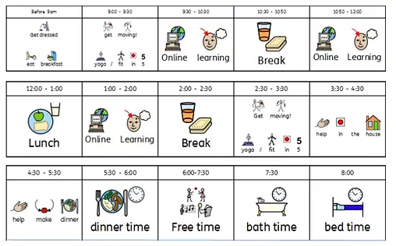

Accessing Remote Education

How will my child access any online remote education you are providing?
For Nursery and Reception, resources will be shared via Class Dojo; For Years 1-6, we will deliver online learning with Microsoft Teams.

If my child does not have digital or online access at home, how will you support them to access remote education?
We recognise that some pupils may not have suitable online access at home. We take the following approaches to support those pupils to access remote education:
- We have a limited number of school devices which we can loan to families. If you wish to request to borrow a device, please email: sbm@st-lukes.towerhamlets.sch.uk
- We also have a limited number of free data SIM cards available to help families stay connected. These SIMs are compatible with smartphones, tablets and other devices with a SIM card port. If you need support with internet access, please email:
homelearning@st-lukes.towerhamlets.sch.uk
- Ultimately, we want to support all our families in accessing the online remote education via Microsoft Teams. We will endeavour to do all we can to support families in accessing this remote education.
How will my child be taught remotely?
We use a combination of the following approaches to teach pupils remotely:
- face-to-face sessions
- pre-recorded teaching (e.g. Oak National Academy lessons, video/audio recordings made by teachers)
- textbooks and reading books pupils have at home
- commercially available websites supporting the teaching of specific subjects or areas, including video clips or sequences (e.g. BBC Bitesize, Oak Academy, PurpleMash, White Rose Maths)
- possibly long-term project work and/or internet research activities
- in some very limited cases, printed paper packs produced by teachers (e.g. workbooks, worksheets)

Engagement and feedback

What are your expectations for my child’s engagement and the support that we as Parents and Carers should provide at home?
As long as children are well enough, we expect all our children to engage with the remote education. This is a daily requirement for all pupils. All teachers and support staff will be supporting pupils daily, therefore, we need your support as parents to set routines and expectations for your child’s learning at home. Teachers will be delivering new teaching on new topics therefore it is crucial that all children engage with the remote learning to help minimise gaps in their learning.

How will you check whether my child is engaging with their work and how will I be informed if there are concerns?
Senior leaders, teachers and support staff all work together to monitor pupils’ engagement with their online learning. We make regular checks through the week by viewing engagement on Teams to see who has viewed/completed assignments etc. and also by liaising with the class teacher.
If we are concerned about a child’s engagement, we will make a call to Parents/Carers to discuss how we can support.

How will you assess my child’s work and progress?
Feedback can take many forms and may not always mean extensive written comments for individual children. For example, whole-class feedback or quizzes marked automatically via digital platforms are also valid and effective methods, amongst many others. Our approach to feeding back on pupil work is as follows:
- we give individual feedback on assignments in Teams
- we give feedback to individuals/whole-class via posts in Teams
- teachers will give feedback on work completed by the deadline set. Please note that if work is submitted past the deadline set then it will be acknowledged by the teacher but may not be marked in detail.

Additional support for pupils with particular needs

How will you work with me to help my child who needs additional support from adults at home to access remote education?
We recognise that some pupils, for example some pupils with special educational needs and disabilities (SEND), may not be able to access remote education without support from adults at home. We acknowledge the difficulties this may place on families, and we will work with Parents and Carers to support those pupils in the following ways:
- our school SENCO will work closely with the families of SEND children to support and advise how best to deliver their education under the circumstances.
- Nursery and Reception teachers will set home learning tasks that younger children can access at home, as well as being available to communicate via class dojo.

Here is an explanation of how to help your child access the online learning:
- Log onto the website www. https://www.rmunify.com/ The homepage looks like this:
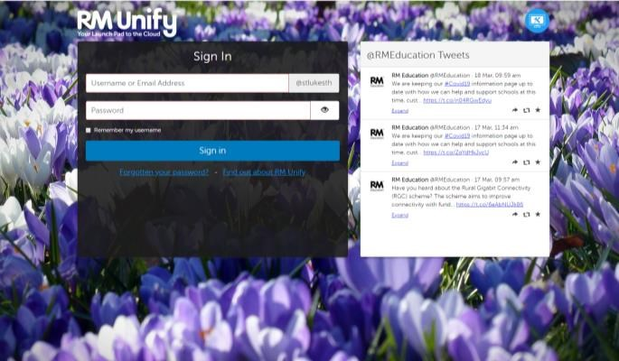
Children logon on with their username ___________________@stlukesth The password is: Stlukes2020!
Usernames will contain your child’s first initial and their last name (with the exception of the children that have the same initials, these will contain a number. For these their logins will be given individually). For example Josh Smith would be JSmith

- This brings you to the ‘Launchpad’
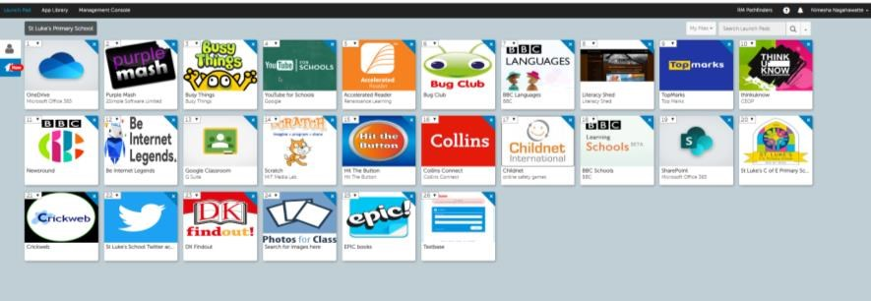
The Launchpad has tiles with shortcuts to other useful websites

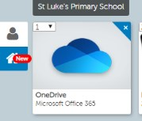
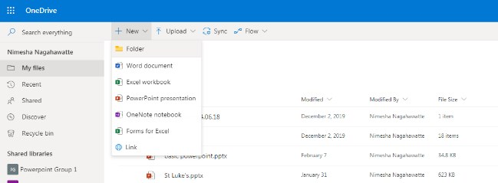
- Children click on ‘Onedrive’

Here, children can create Word/Powerpoint/Excel documents, should they need to.
- Go to the ‘waffle’ in the top left corner Open ‘Teams’
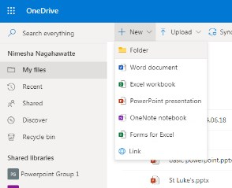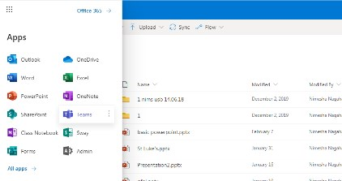

- Children click into their class team i.e. Oak Class or Year 3 etc.
This is a ‘virtual classroom’. Here, the teacher will post a message giving instructions on the tasks. Children and teachers can post messages to each other to discuss the work.
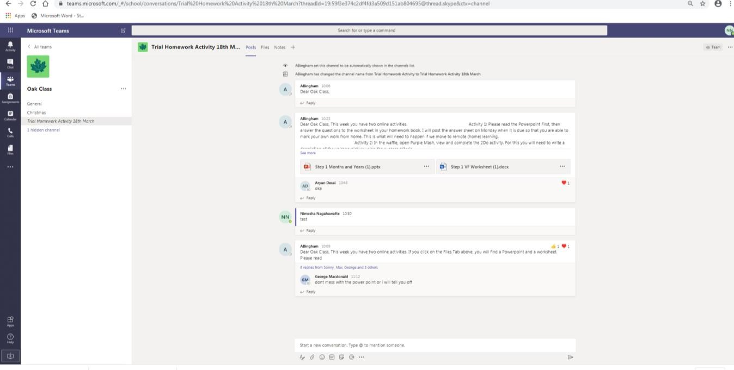

As this is a place for teachers and pupils to discuss their work, we ask that parents do not post any messages in this forum.
- To visit PurpleMash, go to: https://www.purplemash.com/stlukese14
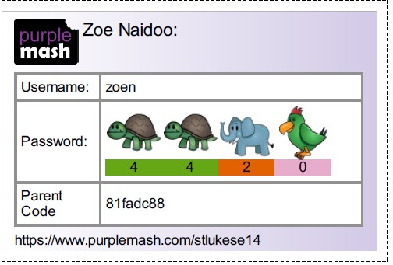

  - Each child has a unique PurpleMash login, see example above.

7)

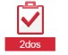
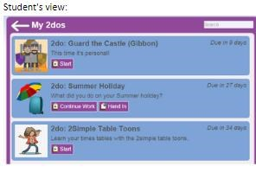
Children should click on the red ‘2dos’ logo to see what tasks have been set. They will appear as a list.

If ever the 2do function does not work, children can search for the task in the search bar.

To complete a 2do:
a): Children should click on the 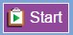 button. This will take them to the work that needs to be completed.
b): Complete the work. When the work is completed, children should save it. This will save the work into a folder called 2dos for the Teacher to mark. Children can only see their completed assignments within the 2dos application.
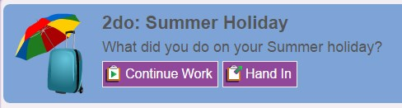
c): Once a pupil has saved their work, they can continue working on it or hand it in.
Pupils can add a typed comment and also an audio comment for the teacher when they click the 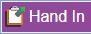 button.
Once a piece of work has been handed in, it can no longer be changed.
d): Once a piece of work has been handed in, it will move to the bottom of the 2dos list. Pupils can click on the 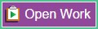 button to view their work or save it to "Online Work".
e): When the teacher who set the 2do has marked the work, students will receive a notification telling them that their work has been marked. Comments will show under the 2do.
You're done!

8) Online reading with EPIC and Bug Club
- EPIC is a free digital library with a range of books which are matched to Accelerated Reader levels.
- Teachers will create an account for their class and children will receive a login code
- Please note - these books can only be accessed in school hours
- www.getepic.com/sign-in
- There is also a quick link on the Launchpad
- Your child’s EPIC login will be shared in your child’s tea on RM Unify by their class teachers.
- Bug Club has books for Early Years up to Year 3.

Go to www.activelearnprimary.co.uk
Enter your child’s username. This will be the first 4 letters of their first name and the first 4 letters of their last name all in lowercase letters.
For example Josh Smith will be joshsmit
The password is: Stlukese14!
School code is: rxkc

Here are some ‘How-To’ videos which you can watch to see how to view and hand-in assignments:
Introduction to Assignments
Working on Assignments
How to upload work
How to view feedback
How to respond to feedback to edit work

To safeguard teachers and pupils, private chats and private video chats are prohibited (unless approved by SLT and parents in the cases of children communicating with the Learning Mentor and other external agencies).
In line with our school values, we expect communication to be respectful, kind and positive. Teachers have the right to delete or mute inappropriate messages.

Teachers will be working hard to plan creative tasks for your children and look forward to being able to communicate with them while they learn from home. We are aware that much of the home learning provided is via technology so we will also plan offline, real-life activities to balance the screen time. We do not expect children to be sitting in front of their devices for long periods of time so please ensure your child has regular screen breaks.
Please also be aware of your internet filtering at home and monitor your child’s online activities.

Another thing to consider is that as many parts of the world are working from home now, there may be high volumes of traffic to certain websites, at certain times of the day (peak times are predicted to be 12pm-7pm). This may mean some websites take more time to load.

If you have any queries regarding the home learning, please email
admin@st-lukes.towerhamlets.sch.uk and we will do our best to support you and your
child.
Best Wishes,
St Luke’s Staff

