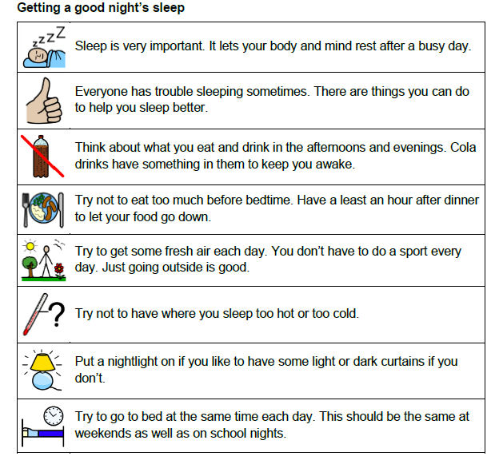
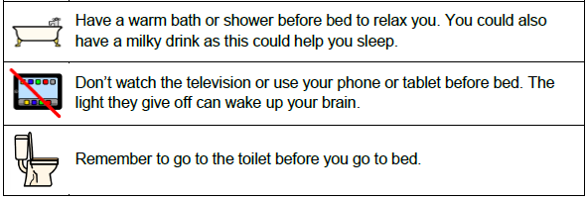
Great Ormond Street Hospital for Children
Sleep hygiene in children and young people handout https://media.gosh.nhs.uk/documents/Sleep_hygiene_F1851_FINAL_Jun20.pdf

