My Class Is Coming Back

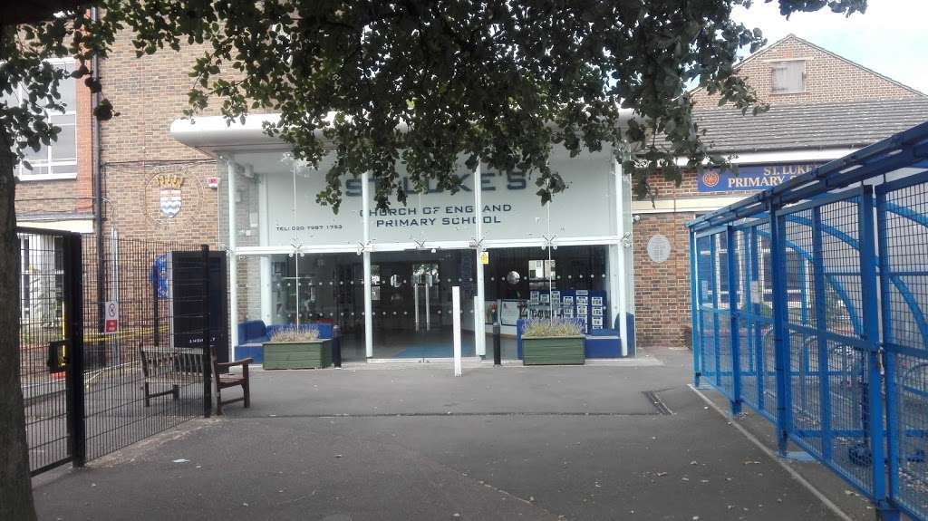

For the last few weeks some of my class have been in school and some of my class have been at home.

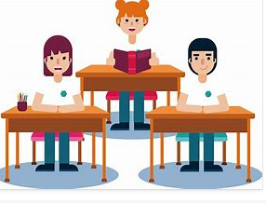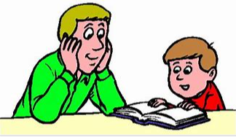

We have all been learning.
In school the grown-ups have been helping us, whilst mums, dads and other people have been helping children at home.

On 8th March everybody will be coming back to school, including nearly all of our teachers.
This may seem different.
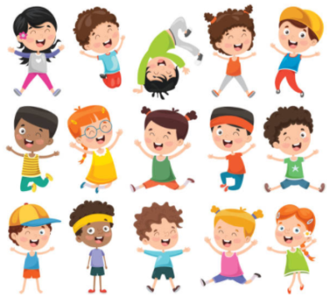
There will be more people in the classroom - it may feel more crowded.
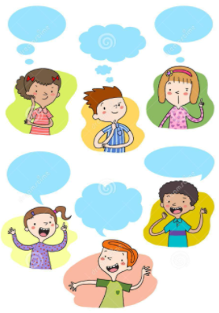
More people will make it a bit noisier – we are allowed to wear ear defenders.
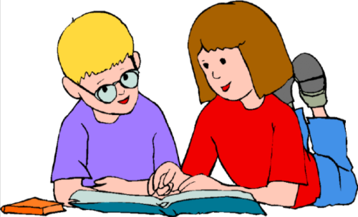
As there are more children we may have to wait a bit longer to get help with our work – our friends may be able to help us.
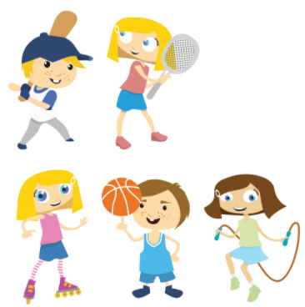
There will be more children in the playground – this means more children that we can play with.

Although things may be different we will soon get used to having all of our teachers and friends back in school with us.

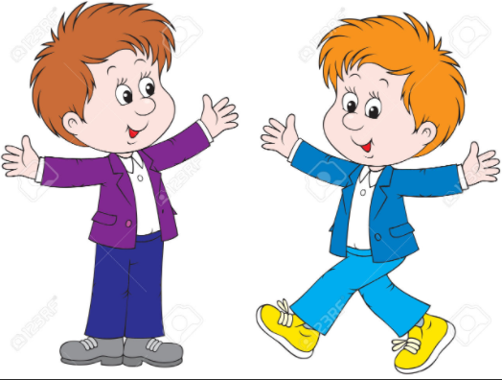

Our teachers know that we may need a little while to get used to things. If we are worried about anything we can talk to:

- Our teachers
- Our TAs
- Harriet or Fiona
- Our grown ups at home

We will soon get used to having everyone back in school.

