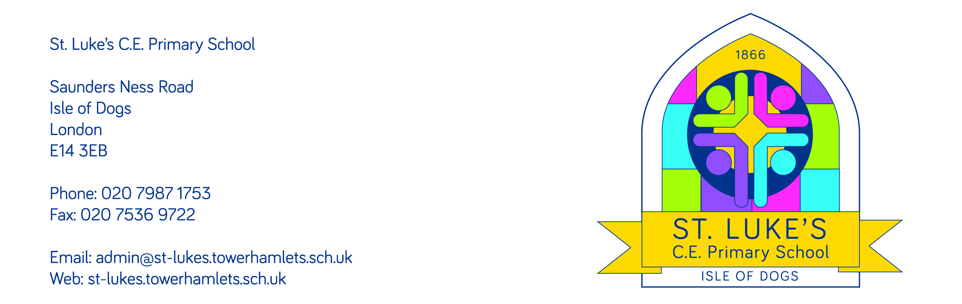
03 September 2020

Dear Parent,
Welcome back for the Autumn term, 2020. We are delighted to see you and your child returning to school today.

As we all have a social responsibility to protect each other by doing our best to reduce the likely transmission of Covid – 19 virus, please can we ask that you confirm your position in relation to the following statements:

Name of child: | Please tick if true
I can confirm that my child does not have any of the commonly observed symptoms of Covid – 19:
- A new and persistent cough;
- A high temperature/fever;
- A loss of taste;
- A loss of smell.
I can confirm that to the best of my knowledge, my child is in good health.

We ask this because the Covid – 19 virus can present with different symptoms and so we are asking that children who appear to be ‘off colour’ are not brought to school until they are tested.
I can confirm that no one in our household has the commonly observed symptoms of the Covid – 19 virus.

I can confirm that no one in our household has been in the company of anyone who is known to have the Covid – 19 virus and is therefore self isolating.

I can confirm that no one in our household is extremely clinically vulnerable and therefore needs shielding.

I can confirm that if the school need to contact me today, I will be available.

If not, please write below, the best person to contact and their number so we can check against our Management Information system.

Please understand that if your child develops the symptoms of Covid-19 during the school day, we will isolate them and contact you to come and collect them immediately. You will then be asked to ensure your child has a Covid-19 test and you will only be able to return your child to school once you have shown us a negative test result.

Please also understand that if your position on any of the above statements changes during the year ahead, it is imperative that you notify us immediately.

Thank you for working in partnership with us during this challenging time.
Yours sincerely,
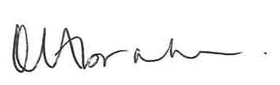

Rebecca Abrahams

